Tender text – Specification document – Product description

BENCH PROFILES
Reinforced bench profile made from solid recycled plastic material, colored throughout.
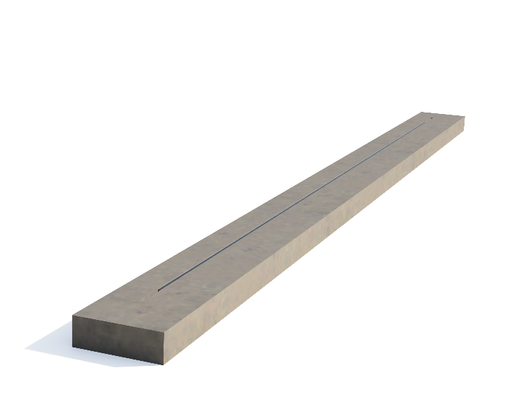

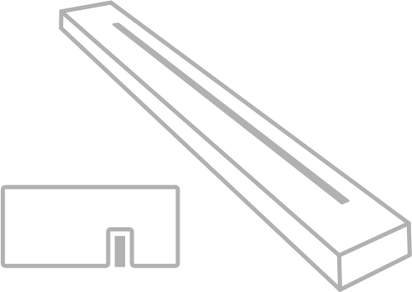

Description
The boards, measuring 4 × 12 × 180 cm or 5 × 12 × 180 cm, are made of mass-colored recycled plastic.
They are equipped with a 150 cm metal reinforcement strip, positioned off-center to allow for central screw fixing.
These boards are designed for the renovation of park benches and outdoor seating, offering a durable alternative to wood.

The maximum span is 145 cm.

Measurements
Length: 180 cm
Width: 12 cm
Height: 4 cm

Length: 180 cm
Width: 12 cm
Height: 5 cm

Weight
4x12x180 cm +/- 9 kg / pc
5x12x180 cm +/- 12 kg / pc

Material
De reinforced bench profiles are made from 100% high-quality recycled plastic (PE and PP), and coloured throughout. The surface is knot-free, uniform in colour, and features a lightly glossy, grained texture. .

Properties
The boards are made from recycled plastic and is:
- maintenance-free
- weather-resistant
- recyclable
- rot-proof
- graffiti-resistant
- splinter-free

Colours
The bench profiles are available in standard grey, black, brown, beige, and green

Transport
The bench profiles are transported on pallets of 72 pcs.
Loading and unloading of the pallet is done with a forklift..

Maintenance
De profiles are maintenance-free. The moisture absorption of the boards and beams is less than 0.29%, meaning that substances such as oil, grease, and paint do not adhere and leave no stains. Cleaning with water and, if necessary, a suitable cleaning agent is sufficient.

Unit
Unit of measurement: pcs.

